Front end performance optimization

Setting a budget

http request is asking a web server for info - css JS images

target load time is the budget

page weight is the total number to load

stakeholders – customers

designer, front end engineer,

Measuring performance

Determine if goals re being met

Are optimization are helping or hurting

Chrome DevTools

J query plugin to enlarge pics when clicked

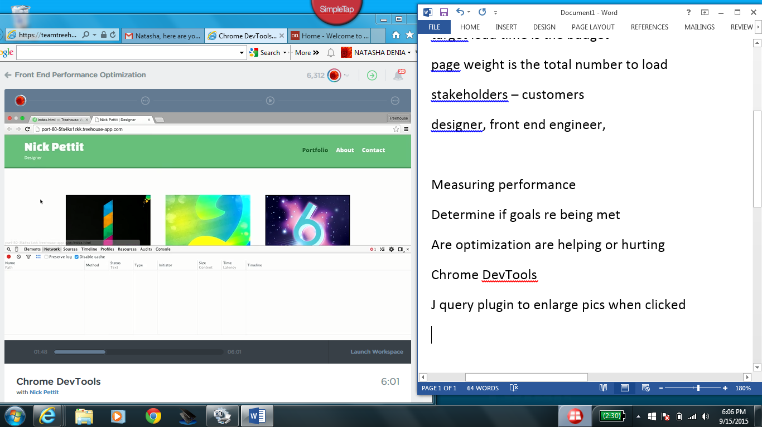

To figure out what assets are loading\

Name and url path of the resource –

Not found in red

Click column header to sort

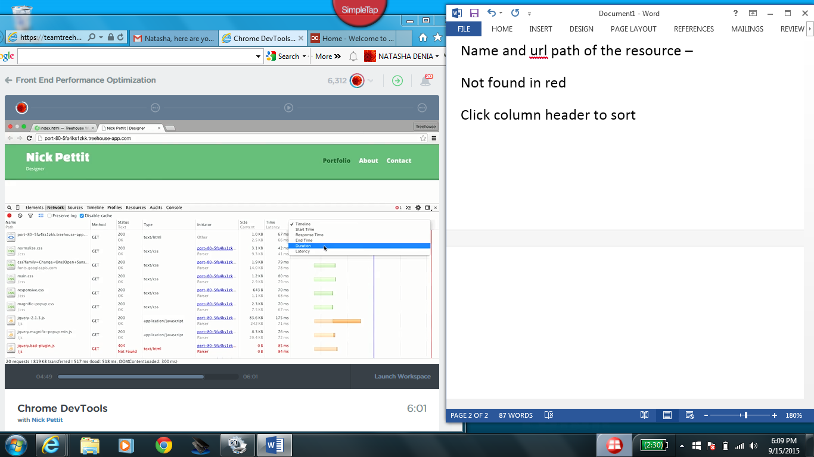

Duration sows which asset took the longest

Stal

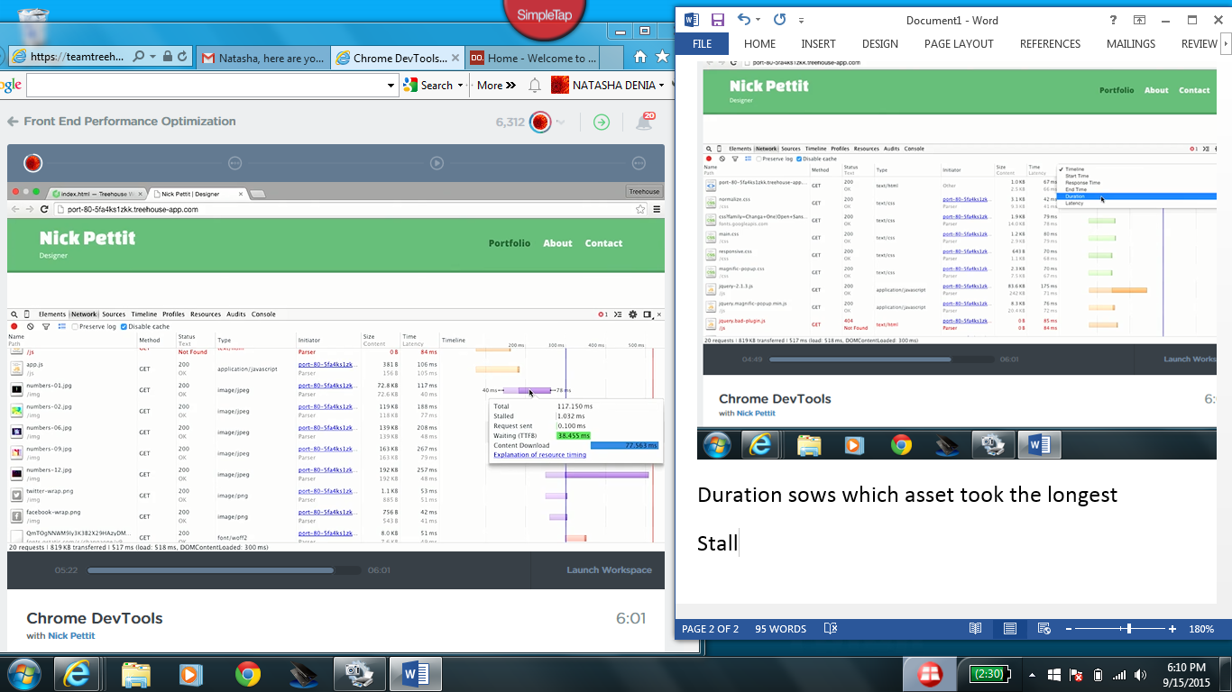Devtool are only for your browser, your computer Another user may have a difference exp

Google PageSpeed is a family of tools that can help you

0:03 optimize the performance of a website.

0:06 The PageSpeed website is available at developers.google.com/speed

Install page speed inside analyze with chrome

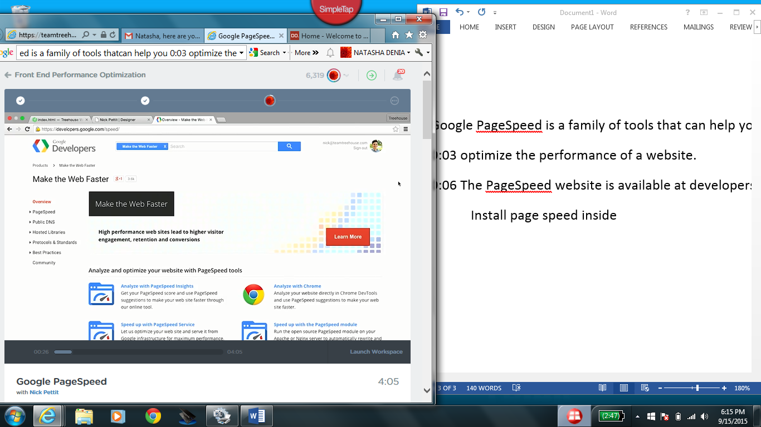

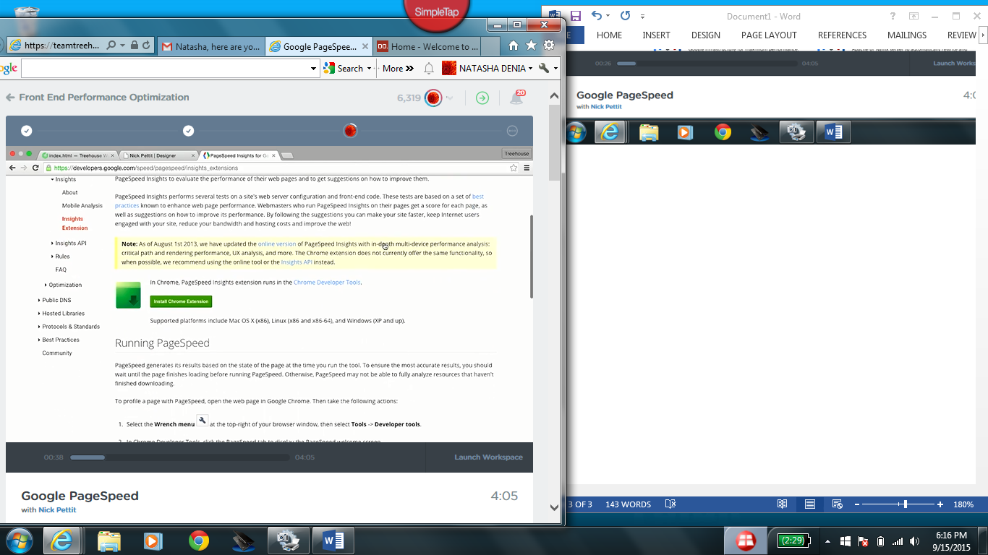

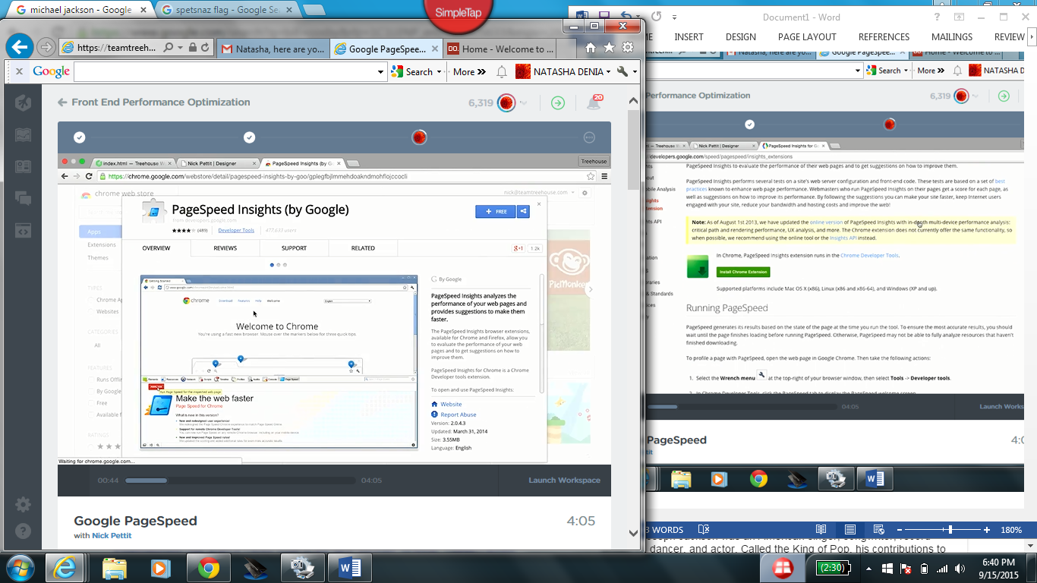

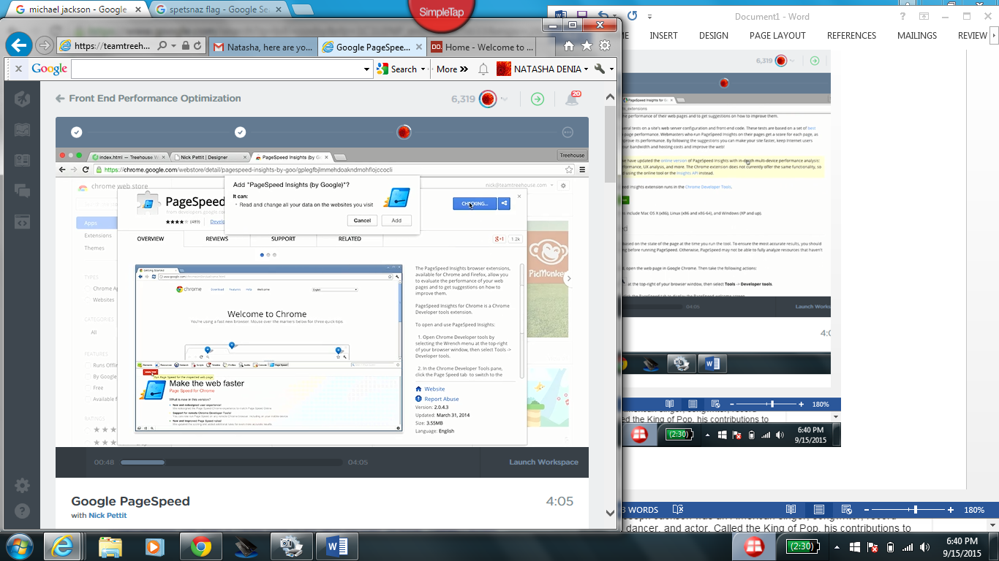

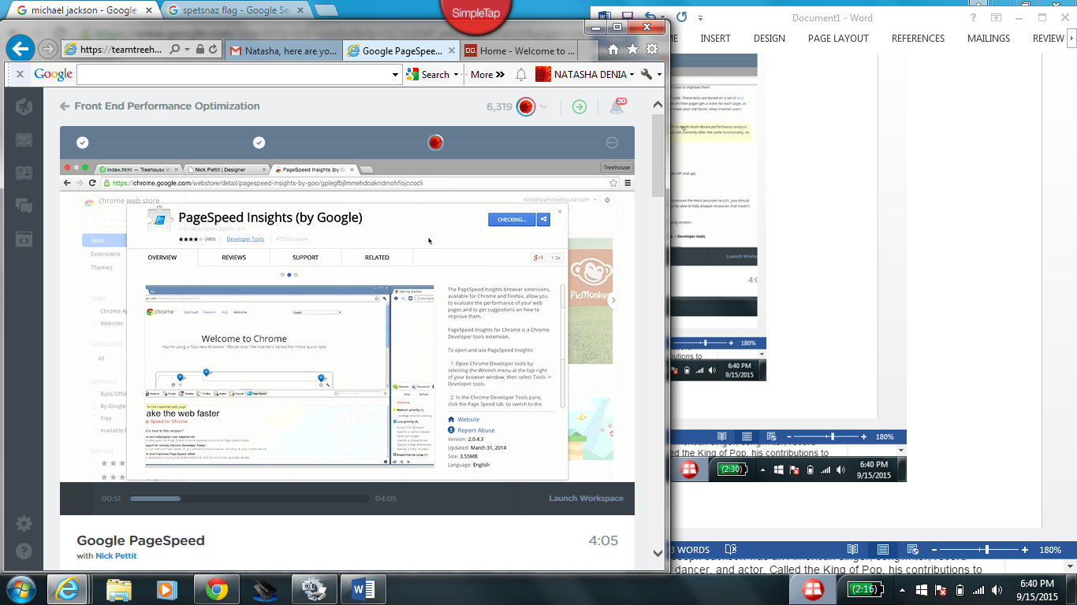

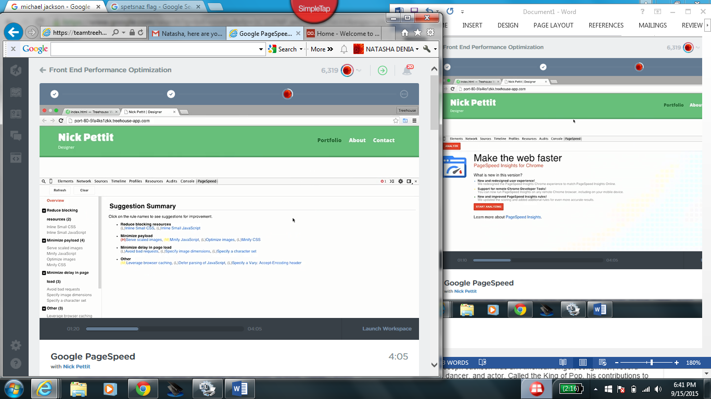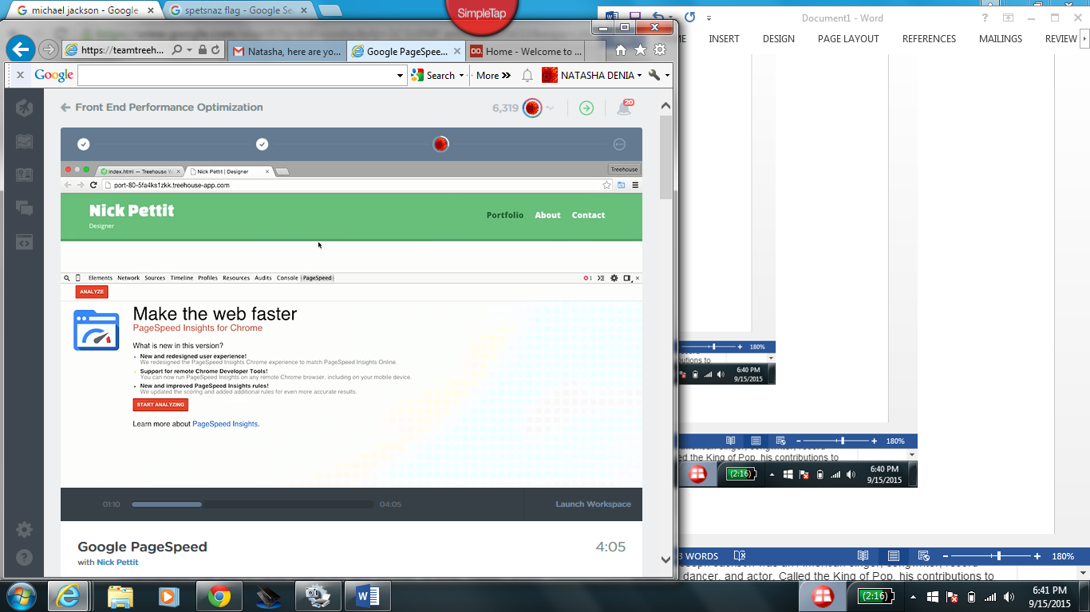

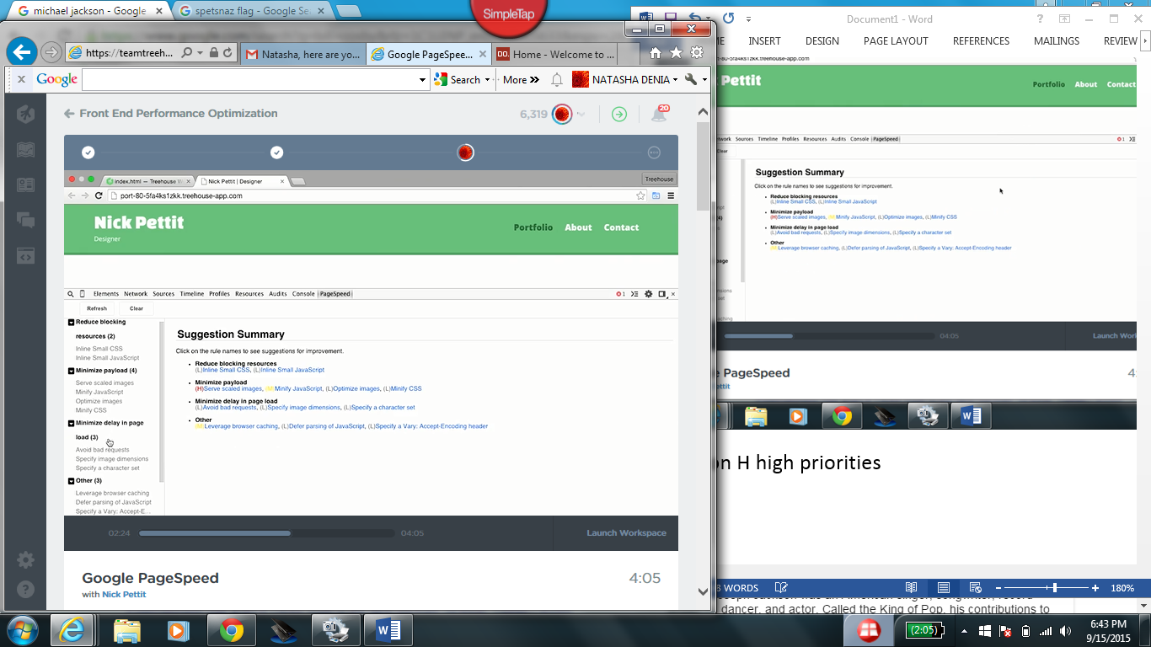

Focus on H high priorities

Network tab refresh

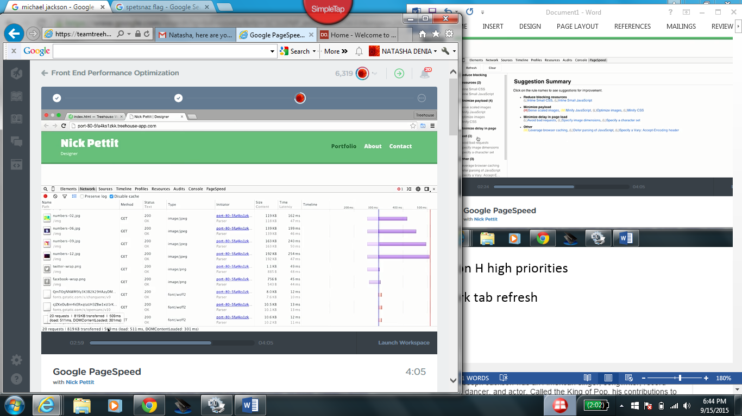

Repeat refresh loadtime will change

Goal: Fewer request, loadtime and